Sierra Shaw

Final Project

I built off my past projects in the beginning and went from there. I based my project of the app game “Slither.io”. I attempted to code two different characters, a Player and an Enemy/Enemies. The player is a bright green ball that follows the position of your mouse as you guide it around the canvas. Your goal is to avoid objects larger than you and bump into objects smaller than you to gain points. I coded the boundaries for the moving objects so they could not go off the canvas and never be seen again based on their diameter and the width and height of the canvas. They would bounce off the walls in all directs and their speed would change. I attempted to code that whenever the diameters of the Player and Enemy intersected, one or the other would change depending on the size. Music was added and set to a timer so you would have to collect as many points as possible before the timer ended. The Music sped up the closer the timer got to zero to increase pressure and drama on the player and intensify the game. I did succeed in creating a server but something went wrong with my sketch, so who knows.

In the game Slither.io you start out as a small snake like creature and slither around as you eat glowing dots and your smaller fellow players and avoid the larger ones. You online with whoever else is playing at the moment. The more you eat the larger you grow, the more points you gain. The photo on the left is the original game and the photo on the left is what is should have looked like if I had any skills in coding.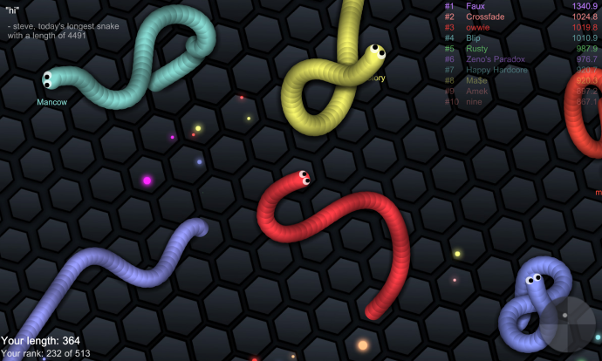 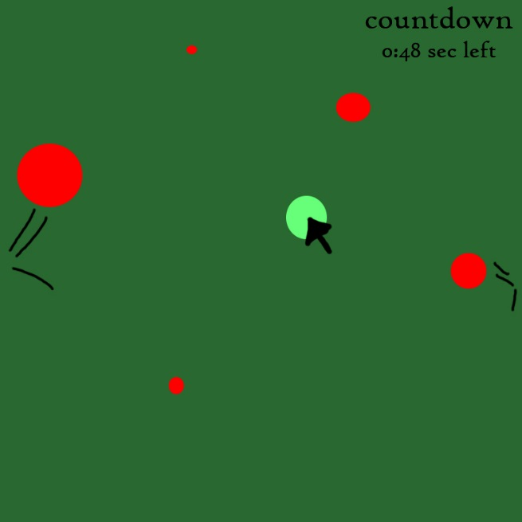

The whole project was a problem for me because struggle with coding in general. Specific problems for me was remember certain ways to do things, finding solutions on the internet, and time. I couldn’t remember everything I needed to know from the past semester and I couldn’t find answers on the internet or with people I knew. When I was able to find a few answers with my professor (you) I was extremely pressed for time and brain was exhausted from all my other projects for other classes where I was literally booked from 9 am to at least 7 pm, sometimes later. Next time, I need to start a little earlier and prepare for when other projects to take longer to complete than expected.

I don't know what it is about coding but my brain cannot handle it, at least for now. This was a great learning experience and maybe someday I'll get it but that day is not today. I'd like to thank you for teaching us and being patient with me. One day I want to focus on learning more about and mastering coding maybe during a summer or another class in the future. Because it is something I’m interested in but takes a while to wrap my brain around.